# LAB # 1: Computer System vs Raspberry Pi vs Micro-Controller Unit Board

**Objective:**

* To understand basic computer hardware parts. Raspberry pi and Micro-controller unit boards.
* To identify placement of different components of computer hardware, Raspberry pi and Micro-controller unit boards.
* To write observation.

**Software/Tools:**

PC

**Activity Time Boxing**

|  |  |  |
| --- | --- | --- |
| Task No. | Activity Name | Activity Time |
| 1 | Pre-Lab Activity ( signed by the instructor) | 5 ~ 10 mins |
| 2 | Lecture + Optional quiz | 20 ~ 30 mins |
| 3 | Performing Experiment | 100 ~120 mins |
| 4 | Results & Evaluation (signed by the instructor) | 10 ~ 20 mins |
| Total Time: 180 | | |

**Introduction:**

**Computer system** Is a collection of entities (hardware, software) that are designed to receive, process, manage and present information in a meaningful format.

Computer system hardware parts:

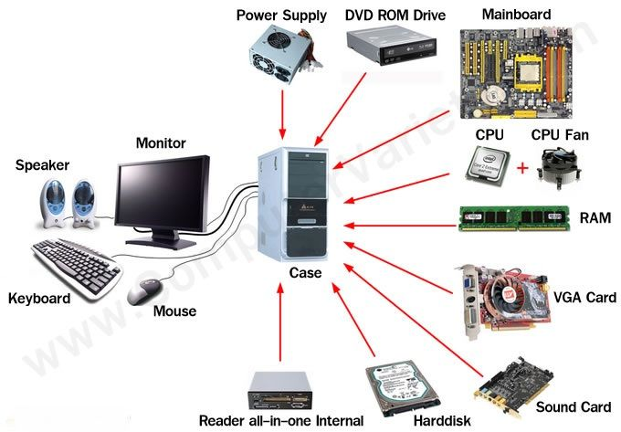

**Motherboard:**

A motherboard is the main [printed circuit board](https://en.wikipedia.org/wiki/Printed_circuit_board) (PCB) found in general purpose computers and other expandable systems. It holds and allows communication between many of the crucial electronic components of a system, such as the [central processing unit](https://en.wikipedia.org/wiki/Central_processing_unit) (CPU) and [memory](https://en.wikipedia.org/wiki/Computer_memory), and provides connectors for other [peripherals](https://en.wikipedia.org/wiki/Peripherals).

The main components of motherboard are as follows.

**CPU** chip refers to a processor, the central processing unit, also called the microprocessor performs all the task that take place inside a computer system. It is also known as brain of computer. It’s the [electronic circuitry](https://en.wikipedia.org/wiki/Electronic_circuit) within a [computer](https://en.wikipedia.org/wiki/Computer) that carries out the [instructions](https://en.wikipedia.org/wiki/Instruction_(computing)) of a [computer program](https://en.wikipedia.org/wiki/Computer_program) by performing the basic [arithmetic](https://en.wikipedia.org/wiki/Arithmetic), logic, controlling, and [input/output](https://en.wikipedia.org/wiki/Input/output) (I/O) operations specified by the instructions.

**Read-only memory (ROM)** is a type of [non-volatile memory](https://en.wikipedia.org/wiki/Non-volatile_memory) used in [computers](https://en.wikipedia.org/wiki/Computer) and other electronic devices. Data stored in ROM cannot be electronically modified after the manufacture of the memory device. Read-only memory is useful for storing software that is rarely changed during the life of the system.

**A hard disk drive (HDD),**hard disk, hard drive, or fixed disk,[[b]](https://en.wikipedia.org/wiki/Hard_disk_drive#cite_note-3) is an electro-mechanical [data storage device](https://en.wikipedia.org/wiki/Data_storage_device) that uses [magnetic storage](https://en.wikipedia.org/wiki/Magnetic_media) to store and retrieve [digital](https://en.wikipedia.org/wiki/Digital_data) information using one or more rigid rapidly rotating disks ([platters](https://en.wikipedia.org/wiki/Hard_disk_platter)) coated with magnetic material.

**A floppy disk drive (FDD),** or floppy drive, is a hardware device that reads data storage information. It was invented in 1967 by a team at IBM and was one of the first types of hardware storage that could read/write a portable device.

**Random-access memory (RAM)** is the most common type of memory used for a Rapid-Access Memory which is a form of [computer data storage](https://en.wikipedia.org/wiki/Computer_data_storage) that stores [data](https://en.wikipedia.org/wiki/Data) and [machine code](https://en.wikipedia.org/wiki/Machine_code) currently being used. A [Random-Access](https://en.wikipedia.org/wiki/Random_access) Memory device allows [data](https://en.wikipedia.org/wiki/Data) items to be [read](https://en.wikipedia.org/wiki/Read_(computer)) or written in almost the same amount of time irrespective of the physical location of data inside the memory.

**Raspberry Pi**

Raspberry Pi is the name of a series of single-board computers made by the Raspberry Pi Foundation, a UK charity that aims to educate people in computing and create easier access to computing education. Raspberry Pi operates in the open source ecosystem: it runs Linux (a variety of distributions), and its main supported operating system, Raspbian, is open source and runs a suite of open source software.

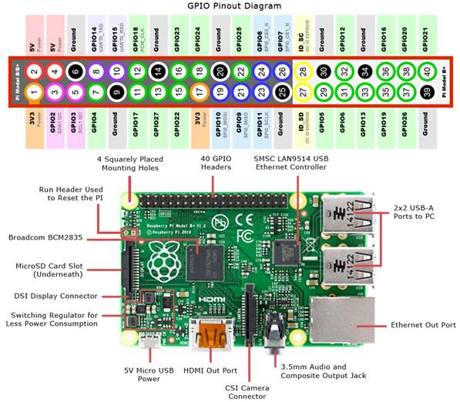

**Memory**

The raspberry pi model Aboard is designed with 256MB of SDRAM and model B is designed with 51MB.Raspberry pi is a small size PC compare with other PCs. The normal PCs RAM memory is available in gigabytes. But in raspberry pi board, the RAM memory is available more than 256MB or 512MB.

**CPU (Central Processing Unit)**

The Central processing unit is the brain of the raspberry pi board and that is responsible for carrying out the instructions of the computer through logical and mathematical operations. The raspberry pi uses ARM11 series processor, which has joined the ranks of the Samsung galaxy phone.

**GPU (Graphics Processing Unit)**

The GPU is a specialized chip in the raspberry pi board and that is designed to speed up the operation of image calculations. This board designed with a Broadcom video core IV and it supports OpenGL.

**Ethernet Port**

The Ethernet port of the raspberry pi is the main gateway for communicating with additional devices. The raspberry pi Ethernet port is used to plug your home router to access the internet.

**GPIO Pins**

The general-purpose input & output pins are used in the raspberry pi to associate with the other electronic boards. These pins can accept input & output commands based on programming raspberry pi. The raspberry pi affords digital GPIO pins. These pins are used to connect other electronic components. For example, you can connect it to the temperature sensor to transmit digital data.

**XBee Socket**

The XBee socket is used in raspberry pi board for the wireless communication purpose.

**Power Source Connector**

The power source cable is a small switch, which  is placed on side of the shield. The main purpose of the power source connector is to enable an external power source.

**UART**

The Universal Asynchronous Receiver/ Transmitter is a serial input & output port. That can be used to transfer the serial data in the form of text and it is useful for converting the debugging code.

**Display**

The connection options of the raspberry pi board are two types such as HDMI and Composite. Many LCD and HD TV monitors can be attached using an HDMI male cable and with a low-cost adaptor. The versions of HDMI are 1.3 and 1.4 are supported and 1.4 version cable is recommended. The O/Ps of the Raspberry Pi audio and video through HMDI but does not support HDMI I/p. Older TVs can be connected using composite video. When using a composite video connection, audio is available from the 3.5mm jack socket and can be sent to your TV. To send audio to your TV, you need a cable which adjusts from 3.5mm to double RCA connectors.

**Difference between Arduino & Raspberry Pi:**

**Raspberry Pi:**

**Type:** Single-board computer.

**Purpose:** Functions like a full computer; capable of running complex programs, handling multimedia, and networking.

**Programming:** Can run a variety of programming languages, and supports Linux-based OS (like Raspberry Pi OS). You can run multiple programs simultaneously.

**Operating System:** Runs a full operating system, typically a version of Linux.

**I/O:** Offers GPIO pins for hardware interaction, but with more computational power and memory than Arduino.

**Use Case:** Ideal for projects requiring more processing power, like running a web server, building a media center, or learning programming.

**Arduino:**

**Type:** Microcontroller board.

**Purpose:** Ideal for controlling sensors, motors, and other hardware. It’s great for real-time applications and simple tasks.

**Programming:** Programs are written in C/C++ using the Arduino IDE. It runs a single program at a time.

**Operating System:** No operating system; it runs a single program directly on the hardware.

**I/O:** Directly interacts with hardware through pins. Limited computational power and memory.

**Use Case:** Best for projects requiring direct hardware control, such as home automation or simple robotics.

**Microcontroller Architecture:**

A microcontroller is a compact integrated circuit designed to govern a specific operation in an embedded system. It typically includes a processor (CPU), memory (RAM, ROM), and input/output (I/O) peripherals on a single chip.

**Architecture Types:**

**Harvard Architecture:** Separates memory and data paths for instructions and data, allowing simultaneous data and instruction fetching (e.g., AVR microcontrollers in **Arduino).**

**Von Neumann Architecture:** Uses a single shared memory space for both instructions and data, which can be simpler but potentially slower.

**Processor and Core:**

The processor, or core, is the "brain" of the microcontroller, responsible for executing instructions from the program stored in memory.

**Types of Cores:**

**8-bit Core**: Common in simple microcontrollers (e.g., ATmega328 in Arduino Uno). Suitable for basic tasks.

**32-bit Core**: Used in more advanced microcontrollers (e.g., ARM Cortex-M in STM32 boards). Offers better performance for complex tasks.

Memory Types:

**Flash Memory:** Non-volatile memory used to store the program code. It retains data even when the power is off.

**SRAM (Static Random Access Memory):** Volatile memory used for temporary data storage while the microcontroller is operating.

**EEPROM (Electrically Erasable Programmable Read-Only Memory):** Non-volatile memory used to store small amounts of data that must be saved between power cycles.

**Input/Output (I/O) Ports:**

Microcontrollers have digital and analog I/O pins to interact with external components like sensors, LEDs, and motors.

**Digital Pins:** Used for binary signals (HIGH/LOW).

**Analog Pins:** Used for analog signals, which can be converted to digital using an Analog-to-Digital Converter (ADC).

**Communication Protocols:**

Microcontrollers often need to communicate with other devices. Common protocols include:

**UART (Universal Asynchronous Receiver/Transmitter**): Simple serial communication for point-to-point data transfer.

**I2C (Inter-Integrated Circuit):** Used for communication between multiple peripherals using only two wires (SDA and SCL).

**SPI (Serial Peripheral Interface):** Used for high-speed communication between a microcontroller and peripheral devices.

**Timers and Interrupts:**

**Timers:** Internal clocks used to generate precise time delays, measure elapsed time, or generate PWM signals.

**Interrupts:** Mechanisms that temporarily halt the main program flow to respond to external or internal events, enabling real-time processing.

**Power Management:**

Microcontrollers often have different power modes (e.g., active, idle, sleep) to save power during operation, which is crucial for battery-powered applications.

**Programming:**

Microcontrollers are programmed using various languages (usually C/C++) and IDEs (Integrated Development Environments) tailored for specific boards, such as the Arduino IDE or MPLAB X for PIC microcontrollers.

**Peripherals:**

Additional built-in components such as PWM generators, ADCs (Analog-to-Digital Converters), DACs (Digital-to-Analog Converters), and communication modules (e.g., Bluetooth, Wi-Fi) provide extra functionalities to the microcontroller.

General Use Cases for Microcontroller Boards

**Embedded Systems**: Used in embedded applications like appliances, medical devices, automotive controls, and industrial machines.

Prototyping and Development: Ideal for rapid prototyping of hardware projects and development of IoT (Internet of Things) devices.

**Educational Purposes**: Widely used for learning electronics, programming, and system design.

**Micro-controller Unit Boards:**

A microcontroller is a small, low-cost and self-contained computer-on-a-chip that can be used as an embedded system. A few microcontrollers may utilize four-bit expressions and work at clock rate frequencies, which usually include:

* An 8- or 16-bit microprocessor.
* A little measure of RAM.
* Programmable ROM and flash memory.
* Parallel and serial I/O.
* Timers and signal generators.
* Analog to Digital and Digital to Analog conversion

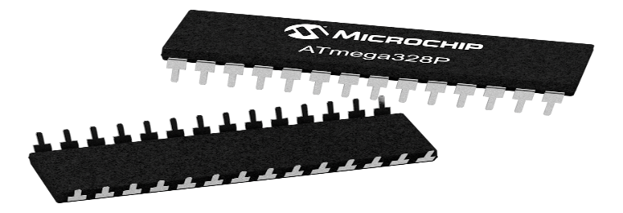

Microcontrollers usually must have low-power requirements since many devices they control are battery-operated. Microcontrollers are used in many consumer electronics, car engines, computer peripherals and test or measurement equipment. And these are well suited for long lasting battery applications. The dominant part of microcontrollers being used now a days are implanted in other apparatus.

**Microcontroller Applications**

Microcontrollers are intended for embedded devices, in comparison to the micro-processors which are used in PCs or other all-purpose devices. Microcontrollers are employed in automatically managed inventions and appliances like- power tools, implantable medical devices, automobile engine control systems, office machines, remote controls appliances, toys and many more embedded systems. By dipping the size and expenditure in comparison to a design that make use of a different micro-processor, I/O devices and memory, micro-controllers formulate it inexpensive to digitally control more & more appliances and operations. Mixed signal micro-controllers are general; putting together analog constituents required controlling non-digital electronic structures.

**Application of Microcontroller in Day to Day Life Devices**

* Light sensing & controlling devices
* Temperature sensing and controlling devices
* Fire detection & safety devices
* Industrial instrumentation devices
* Process control devices

**Application of Microcontroller in Industrial Control Devices**

* Industrial instrumentation devices
* Process control devices

**Application of Microcontroller in Metering & Measurement Devices**

* Voltmeter
* Measuring revolving objects
* Current meter
* Hand-held metering systems

**Lab Tasks:**

**Question 1:**

In the above given raspberry pi module, study the mounted components and write a detailed report on their functions?

**Question 2:**

Given below an Arduino module; Study its layout and write a detailed report on the mounted components and their functions.

